Weekly Lesson Plan-Project Work
Date: July 7, 2014 Classroom: Red Room Study Topic: Healthy Bodies Phase: Two Teachers: Ms. Bobotek and Mrs. Wiest
Discussion/Activity for Meeting Time  What is “My Plate”?  How can we sort food using “My Plate”?  What is exercise? What are some different ways to exercise?  What do you know about running as an exercise? What would you like to know?  Let’s create an obstacle course to move our bodies in different ways. | Fieldwork/Investigation for Center Time  Expert: Mary Corbett, a “My Plate” Ambassador, will come in and teach us more about this FDA program.  Field Trip: We will walk to track on campus to practice running and do some relays.  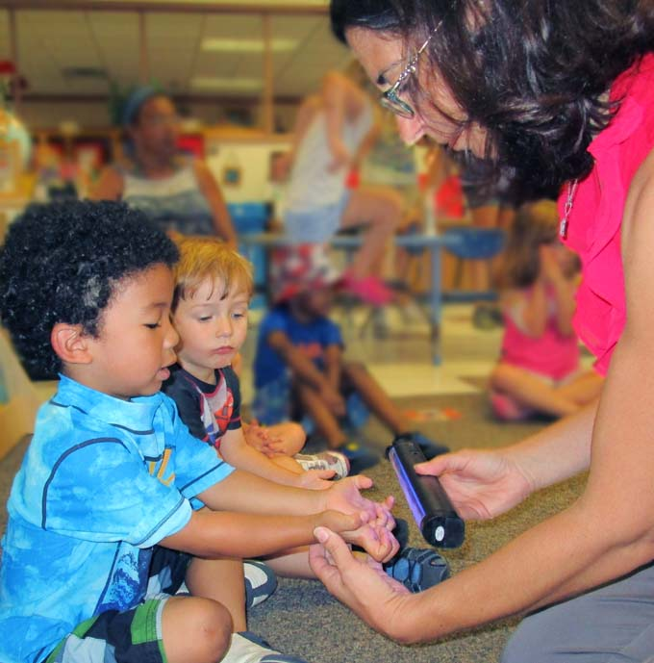 | Representation/Display  Sorting: Using a giant paper plate, children will sort some play food into the proper categories: dairy, protein, vegetables, fruits, and grains.  List: The class will brainstorm a list of ways to exercise and take pictures of their classmates doing some of them.  Design: Children will draw and then create their own obstacle course using materials from the CYC movement closet.
Literature for Story Time: We will read books by Ezra Jack Keats including Goggles, The Snowy Day, and Peter’s Chair.
Mathematical Thinking: Flannel board animals and numbers will be out for children to arrange and count.
Scientific Thinking: A mortar and pestle will be out for children to crush some herbs from the garden and explore their scent.
Cooking: We will make pizza with a whole wheat crust.
Music: Musical bean bag songs will be enjoyed during afternoon meeting time.

